In- House Practical Training

on

**WEB DEVELOPMENT**

Submitted to

Amity University, Lucknow, Uttar Pradesh

In partial fulfilment of the requirements for the award of the degree of

Bachelor of Technology

in

Computer Science and Engineering

by

**RAUNAK SIKKA**

**A7605219040**

Under the guidance of

**Ms. Shikha Singh**

DEPARTMENT OF COMPUTER SCIENCE AND ENGINEERING

AMITY SCHOOL OF ENGINEERING AND TECHNOLOGY

AMITY UNIVERSITY UTTAR PRADESH

**AMITY UNIVERSITY**

–––––––––UTTAR PRADESH–––––––––

**DECLARATION BY THE STUDENT**

I, **Raunak Sikka**, student of B. Tech(CS&E) 5th Semester hereby declare that the term paper titled **“Web Development”** which is submitted by me to Department of Computer Science and Engineering, Amity School of Engineering and Technology, Lucknow, Amity University Uttar Pradesh, Lucknow Campus, in partial fulfilment of requirement for the award of the degree of Bachelor of Technology in Computer Science and Engineering has not been previously formed the basis for the award of any degree, diploma or other similar title or recognition.

The Author attests that permission has been obtained for the use of any copyrighted material appearing in the Project report other than brief excerpts requiring only proper acknowledgement in scholarly writing and all such use is acknowledged.

Lucknow

Date : -

**Raunak Sikka**

**B. Tech (CS&E) 5th Semester**

**A7605219040**

**AMITY UNIVERSITY**

–––––––––UTTAR PRADESH–––––––––

**CERTIFICATE**

On the basis of declaration submitted by **Raunak Sikka** student of B.Tech (Computer Science and Engineering) 5th semester, I hereby certify that the Term Paper titled **“Web Development”** which is submitted to Amity School of Engineering and Technology, Amity University Uttar Pradesh, Lucknow, in partial fulfillment of the requirement for the award of the degree of Bachelor of Technology in Computer Science and Engineering , is an original contribution with existing knowledge and faithful record of work carried out by her under my guidance and supervision.

To the best of my knowledge this work has not been submitted in part or full for any Degree or Diploma to this University or elsewhere.

Lucknow

Date :-

**Ms. Shikha Singh**

Assistant Professor

ASET

Amity University

(Faculty Guide)

**(External Examiner) Prof. (Dr.) Deepak Arora**

Head – CSE & IT

ASET, Amity University, Lucknow

**Wg.Cdr (Dr.) Anil Kumar (Retd)**

Director ASET

Amity University, Lucknow

**AMITY UNIVERSITY**

–––––––––UTTAR PRADESH–––––––––

**ACKNOWLEDGEMENT**

The satisfaction that accompanies the successful completion of any task would be incomplete without the mention of people whose ceaseless cooperation made it possible, whose constant guidance and encouragement crown all efforts with success. I would like to thank **Prof (Dr) Deepak Arora**, Head of Department-CSE, and Amity University for giving me the opportunity to undertake this project. I would like to thank my faculty guide **Ms. Shikha Singh** who is the biggest driving force behind my successful completion of the project. She has been always there to solve any query of mine and also guided me in the right direction regarding the project. Without her help and inspiration, I would not have been able to complete the project. Also I would like to thank my batch mates who guided me, helped me and gave ideas and motivation at each step.

**Raunak Sikka**

**A7605219040**

**Index**

|  |  |  |  |
| --- | --- | --- | --- |
| S.no. | Topic | Page no. | Remarks |
| 1 | Declaration | 2 |  |
| 2 | Certificate | 3 |  |
| 3 | Acknowledgement | 4 |  |
| 4 | Index | 5 |  |
| 5 | Abstract | 6 |  |
| 6 | Introduction | 7 |  |
| 7 | Setting up a website | 8 |  |
| 8 | The need of building web development projects | 9 |  |
| 9 | Web Designing-Principles | 10-12 |  |
| 10 | Domain’s role in web development | 13 |  |
| 11 | Important terms used in web development | 14-15 |  |
| 12 | Included work/practical work done | 16-26 |  |
| 13 | Conclusion | 27 |  |
| 14 | References | 28 |  |

# **Abstract**

We are going to discuss the topic “Web Development” which as the name suggests is related to creation of a website or development of it by the programmer. Web Development or we can say websites are means by which one will promote his or her business or shop in which he/she has done studies and now they want it to reach it to others in the world or locally so as they can act as the converters and earn them money by buying things and in order to do that, you need to know the rules and several points used to create a website which are being discussed in the report below.

An another advantage of this will be that the online shop will be open 24/7 for your clients, throughout the year. Basic advantage or purpose of it will be that people can broadcast and share with others what they are offering them and can reach out good number of clients at a global stage or local stage according to their financial abilities and so on.

**Introduction**

Web development stands for building websites and deploying them on the web pages. It requires the scripting languages for server and also for client side. Now, we are going to discuss about why we need websites. Websites act as a connection between the one who wants to share information and one who is receiving it. For example, we can say that if you are running a business, then it is compulsory that you must have a properly running website to broadcast and show others what you are offering them and reach out good number of clients at a global stage. There are more advantages to it as well like you can open your online shop and sell your products or offer the service you wish online. An another advantage of this is that the online shop will be open 24/7 for your clients, throughout the year. Now we are going to discuss about something relating to how you can setup a website.

# **Setting up a website**

1. In order to set up a website and make the website live, we need to first purchase a hosting plan.
2. Select a domain name for the website.
3. Point the DNS records to the hosting provider.
4. Now, Develop the content that you want to publish on the website.
5. We will need to check if you’ll need to purchase some public certificate and then install it.
6. Lastly, you need to publish that webpage on the internet.

# **The need of building web development projects**

It is very important for us to start making and building the web development projects when we are learning web development because one would not be able to understand the concepts unless he/she learns to apply them to make various projects. Also we could start first with beginner-level projects and after that we can move on one step higher level projects and projects which are more complicated as we proceed in the learning journey of web development projects.

This process of making web development projects requires clever planning plus a large amount of skill-sets. It also tests our brain and skills and we have to take these things as a challenge too and it helps one understand what are their strong and weak points.

# **Website Designing** UI and UX role in web development/designing

Firstly, when we read the term “Website Designing” , we first think about the UI and the UX. UI and UX are two main things which we make use of in web designing, yet they work hand- in-hand . While UI’s purpose is to solve and focus on the design interface and how a user interacts with it, UX focuses on a user’s experience or review as they use your product or service.

Another thing, we can add to the sub-topic is that UX designers will make sure that the website is pleasing and interactive to amplify user’s website experience. The user experience about the website is scaled on the basis of the interactive abilities of the user interface which is created by the UI designers.

# Principles of web designing

Now, we are going to discuss about the principles of web design. There are many points under this which show us the principles of good website design.

1. First point would be Less is More which means simplicity while making a site should be kept in mind. Many websites are there which are over-designed with too many things on the webpage, which distract visitors coming to your site from the purpose of the site.

In effective web designing, one must keep in mind this thing and try to follow simplicity rules. Not only does a clean, fresh design make the site easier to navigate, but the attractiveness though maybe more appealing but time consuming for some users to find their purpose for visiting the website. It is unnecessary, distracting also to users who are not familiar with the UI,UX of the site so it should be made a practice that one should keep in mind that the design features should be limited and that things should be avoided that don’t even serve a purpose or we can say isn’t relevant there.

1. In second point, we can say that a design which you want to be praisable or respectable, that should involve some creativity and natural talent as well. Now, talking about the professionals in the design industry, they understand how to use whitespace. What is Whitespace? Whitespace or we also call it negative space, is that part of the web-page that is “empty” i.e it is that part which is found between the graphic elements, images, and texts on the website. A intelligent use of the design ideas by the creator of the website plus the design elements and not forgetting the whitespace, creates a less distracting and more appealing design of the website, and also guides the visitors where you want them to go.

Next, we can talk about the unforgettable designs of Google’s and Apple’s websites plus also their iconic logos. A simple, clean design, surrounded by whitespace can make a website more effective plus great is what we are trying to tell here. A cheaper and lower quality products often have busy, noisy and ad-oriented designs, and people visiting the website that is the visitors automatically consider a distracting/ noisy i.e what we are trying to explain here is more designed plus lot of design elements website to be definitely promoting a lower quality product which is not apt for the users or the visitors.

1. In third point, we are going to talk about aesthetically appealing – To the right users topic. In this, one has a specific market segment which is your target customer (or client). The design must be crafted explicitly to appeal to that niche. Doing research into the buyer’s habits can also reveal the type of images, editings, and other design features created by you that are appealing to those you want to reach. Each customer have their specific likes and dislikes, and doing research into these likes/dislikes are essential because that way you’ll be able to get success in the aim behind making the website as in the end, it is the customer who will be using your made website and it’ll benefit you. The huge numbers of people visiting your site are useless if they are not those people who will eventually convert your hard work in making the site to actually buy things.
2. Respectful, Honest, and Engaging**-** Social media has had a very significant impact upon communication, both written and spoken. The people visiting the website want them to be engaged into the site in a very “human” way. Even the largest multinational corporations have been forced to put a human face on what they do. The basic concept and what we are trying to say here is that people want the developer of the site to be honest and appreciate the real self of the person who’s creating the site. Your company can participate in various charity events or can donate some time writing about or actually doing to various causes you care about. Let the visitors know who you are, what you like to do for others. Become real.
3. Designed for Usability and Functionality- In website designing, usability and functionality must drive each decision. In order for you to achieve a clear, easy, and ultimately a direct path to conversions which we have discussed above till now, we have to admit that both the design and technical problems, barriers come into play.
4. Adhering in design, down to the Details- Your enterprise about which you are making your website has a unique personality, as an entity and that personality is showcased through your service, your past history, how you take your things, see your mission, your aim and by the actions of every member of your team. When one is communicating the different and new qualities of the business through design it involves making each and every element, and making the website to the details, a reflection of that personality. There is nothing like small or minor details in a design – every piece of the words or the design you have thought of to implement must fit together well seamlessly, and create an appealing appearance whose purpose will be to serve & support the appeal of your brand.
5. Talking about the homepage of the website, it must have an initial basic necessities of the purpose of your site like your top plans or if you are providing sale on some product and for example what we are trying to say is user should be friendly and not face any difficulty to browse for main things like your plans etc. landing up in other pages of your site that is website should be appealing in design and usability. Every design feature you’re creating for your website is developed with the specific purpose to inspire the person visiting your site , to find out more – and go deeper into your site, for which one has to be simplistic in design and create easy to access interface for the vistor and in the end, convert and become a customer.
6. Emphasis on What Matters Most- Now comes the last point, the essence of your presentation must clearly speak and show that your business is the place to solve a specific problem or need. The balance between images and the text are just one part of this process. To appeal to the target audience, emphasis must be placed upon what your customer wants most.

For results, it is necessary to research what your customers, as in a group, are looking for, and the questions they are wanting to ask. Then once these needs and wants are identified by you , you can work with these concepts to create a good presentation that will focus more on these colours, designs, and texts.

# **Domain and it’s role here in Web Development**

The domain is one of the important topic which we need not miss while developing a website. The domain can be defined as a collection of knowledge and information about the topic of your website domain the web covers. This includes the information that the users of the website will see and the information the web developers need to design or implement on a web. Then there comes a thing called Domain name which is basically the name of your website by typing which on the search bar people will reach your site. There is this thing in domain name that once you buy it no one else can take it unless you stop renewing your domain name for eg. facebook.com , youtube.com all these are domain names and they pay amount as well to reserve these.

Now under domain, there are some rules that we must keep in mind before we purchase a domain name:

1. We should choose a domain name that can be somewhere close to your brand name, if required. That’s good for people to reach the site everytime when brand or business name is the same as domain name.
2. There is also a thing which is good to keep in mind from knowledge point of view, not a rule as such which is if you are good financially or so, then you can purchase domain names with various extensions such as .com, .net, .info, etc.
3. The domain name should be short. The lesser the number of characters in a domain name, the easier it will be to type, to say to someone, to share with someone and to get shortlisted with ease on social media platforms and in search results for example-google.
4. . The .com domain extension is by far one of the most popular, but it can be tough also sometimes to get specifically only a short and a memorable .com domain name of your choice because it is around for so long or also some maybe already taken by other businesses. If your webpage is serving locally like in Lucknow only or Delhi based for example, then you can buy it with the suffix of your country.
5. If your domain name is not similar to your brand name, then at least one should use specific keywords which may be close to your business and people don’t feel like it is irrelevant domain, for example, sikkanet.com. As the name suggests, we read net here. Whenever we are trying to enter this url, we know that this business is something related to internet. It will help improve your business website’s rank on search engines like google (which increases traffic) and it also makes more sense to your customers and is beneficial to you as well.

# **Some important terms relating to Web Development**

**API**- It’s full form is Application Programming Interface. An API’s work is to enable two different programs to communicate with each other and that can be done by making some parts of the website code available to web developers. These web developers can be useful to use this code, i.e. the API, to build and design the tools and widgets that can be connected to that particular website.

**Bootstrap**- Bootstrap is an open-source frontend framework which is useful for designing websites and web apps. The people who developed it were Mark Otto and Jacob Thornton so as to encourage consistency across the internal tools. Bootstrap is a framework that includes HTML and CSS-based design templates for buttons, tables, navigation, forms and many more, plus not forgetting the JavaScript plugins.

**Frontend**- The frontend of a website is simply known as client-side ,what the end user or we can say the visitor sees on your website and interacts with. Some frontend languages include HTML, CSS and JavaScript, which all have hands in determining or presenting the visual output or visualization of a website to the end-user.

**Cache**- A cache is a temporary storage space for data. The cache is very interesting term to be discussed because when we visit a website, the files that we request to open or we can say the websites that we are opening are automatically stored in the cache. Now, we can understand this by the sort of example like if we are returning to that same website in the near future, the browser will retrieve the necessary files from your cache rather than from the original server—so the webpage will load quicker. This is also the reason what many people wonder as well as to if they are loading their top choice’s website, it loads quicker because of cache as discussed above.

**Code**- Code is something, you can’t call yourself a web developer until you know what code is. Code is simply what web developers use or write using different programming languages they have learned. It is the code which is responsible for the operations on the website.

Suppose, you want to give a payment getaway or you want to add some feature update or add a button that’ll land you to somewhere on your website, all that is possible if you know coding and if you have learned good CSS and HTML concepts.

**CSS and HTML**- stands for Cascading Style Sheets. It is called a markup language and is responsible for the visual elements of a website. HTML which stands for Hypertext Markup Language is also a markup language is used to make and determine the structure and content of the webpage. Web developers will then use CSS to style this content; in other words, CSS role is to tell the browser how will the HTML elements be displayed. On the other hand, CSS is mostly used to apply simply the colours and also determine and set the font size, text size and also the alignment.

**HTTP**- Another acronym to see is HTTP which stands for Hypertext Transfer Protocol which is used to transfer data across the internet. HTTP sends the data, for example say an HTML document or an image from an HTTP server program (a web server) to an HTTP client program (a web browser)

**JavaScript**- While we’re on the discussion of popular languages, another language which is widely used in web development is JavaScript, let’s talk about JavaScript. JavaScript is primarily used as a client-side language that it is embedded into the HTML of a page and sent to the browser. Web Developers usually use javascript with purpose when they want to add automation, animation and interactivity while making the site.

**MySQL***-* MySQL is the world’s most popular open-source database management system. This means it is in itself a database management system. A database is a structured collection of data, and is a necessary component in most websites. A database management system can be defined as a software that manages these databases.

**Text editor**- One of the key tools you’ll use in web development is a Text editor. A text editor is simply a software used to write plain and unformatted text. While making of a website, you’ll use a text editor such as TextWrangler , TextEdit or SublimeText to write your initial code. Then, afterwards, it will be formatted to make it computer-readable.

# **Included Work**

This is the topic which will cover and showcase what all work has been done to make this project and also show screenshots or direct WordPress and software’s work I have performed in my NTCC In-House Practical training. So, firstly talking about wordpress, it made the task possible of website development giving various features for creation of a good website. In order to achieve the working of these softwares some help form e-books, youtube videos and various educational platforms like udemy, unacademy were required by me. After some videos, I was able to crack the procedures and started to implement them on wordpress and finally started with my website.

Now talking about the type of website that has been made, its for a business purpose and I have designed it and given my inputs. It’s a website for a cable tv company which is of my own and I tried to buy domain and all and give it a go. Now under included work, we will see all the work done.

Firstly, starting with an explanation of a screenshot taken of a wordpress page. Here

in the screenshot below, I’ll try to explain some basic things in this.

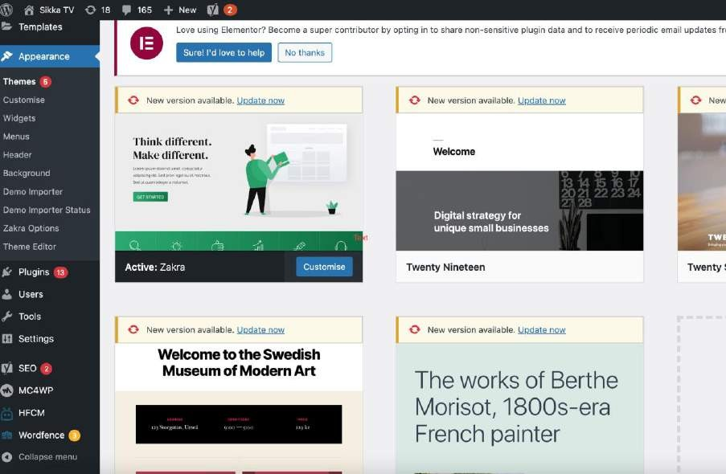

**Fig-1**

Here, in Fig-1, on the top left corner, as the WordPress logo is visible to you. The website is for my own cable tv company “SIKKA TV” as visible on top. Firstly, I’ll go directly onto the appearance section on the website which as the name suggests deals with layout, background images, theme and design which is something which will be appealing to the visitors. Below, I’ll also show screenshot of the design of home page created with appearance and widgets underneath it.

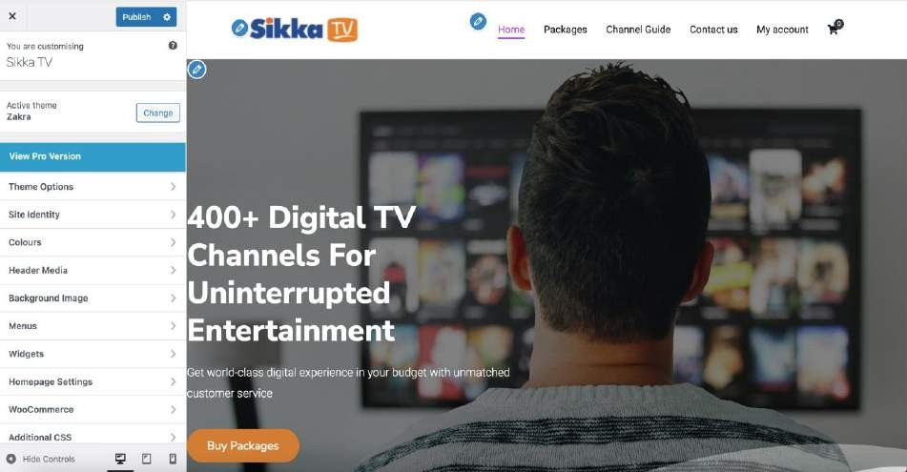

**Fig-2**

Fig-2 is the homepage of my website and as you can see here, when I clicked on widgets several editing options on the left column like theme options, site identity(which covers like the site logo and things related to enhancements to site’s identity), background image etc.

On the top beside website’s logo, we can see an small blue pencil box, after clicking on which we can change the logo and beside it is Home, Packages etc. which we can also edit the similar way.

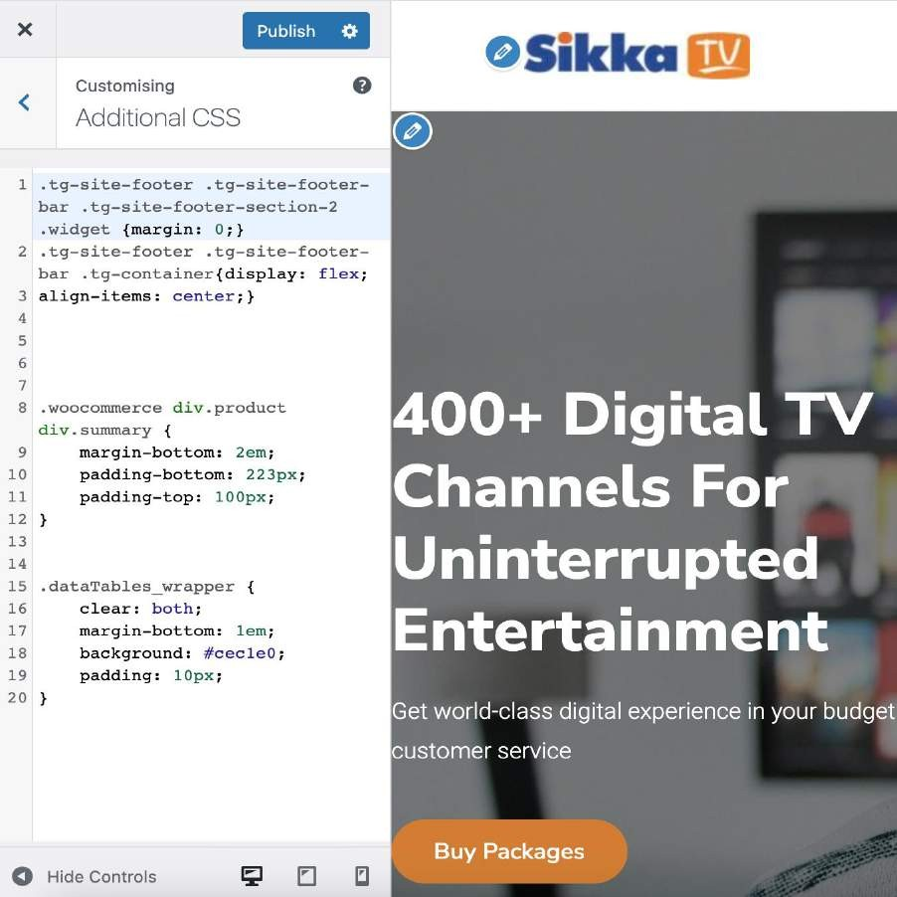

**Fig-3**

In Fig-3, we will talk about the css code that has been used to give these designs a go. Here, while making a website, we have to give everything in written like from the code we can see above, there is a line of code for everything like which thing will appear where, at what pixels, at what distance from where. ‘em’ as we can see above is the font size and 2em is 2 times the current font size. This is basically according to one’s needs. We can do that according to design we want. ‘px’ is simply pixels.

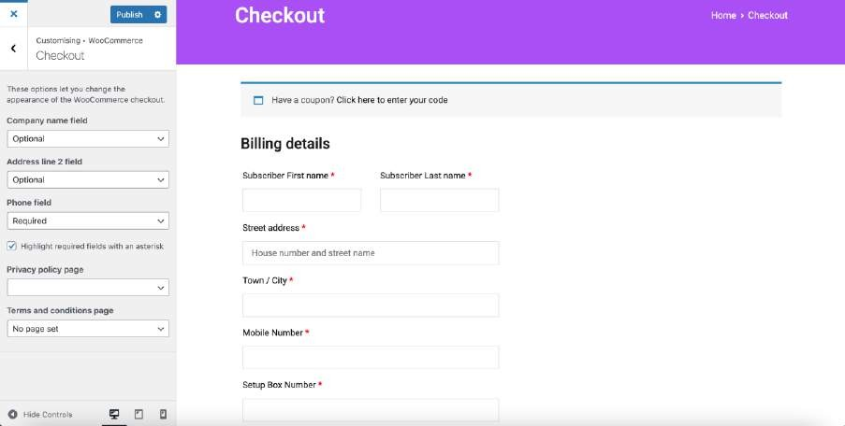

**Fig-4**

Now in Fig-4, we come onto WooCommerce section under which we usually deal with money and checkout page. Here, I have designed a checkout page with Billing details , basic things required for buying a product.

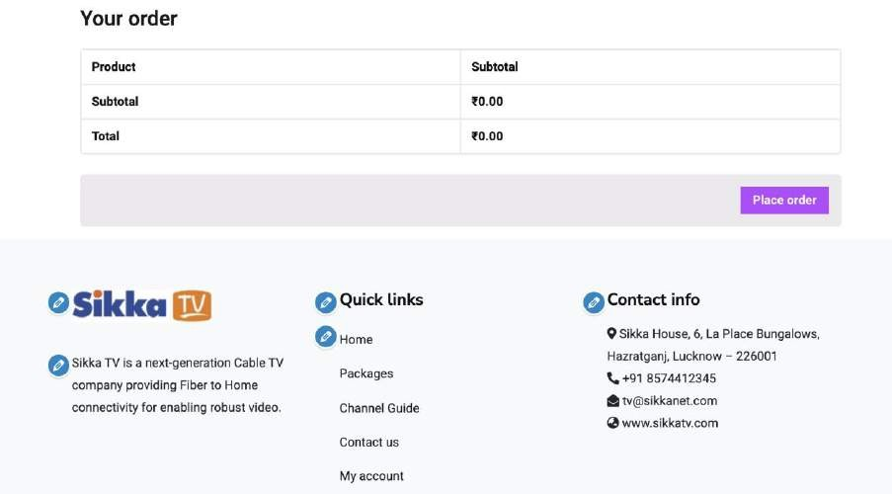

**Fig-5**

This is another image of the same page as above(checkout page) where currently no product is added and hence the subtotal is Rs.0.00

Another thing we can see in the above image is the footer animation under which I have added brief about SIKKA TV, Quick links, Contact info which all are on header as well.

Now, we have discussed enough about animation part. Now, again we’ll go to the wordpress’s home dashboard and now we will discuss little about products images and prices which is our website’s main purpose or motive to sell and earn money online as well as through contact number.

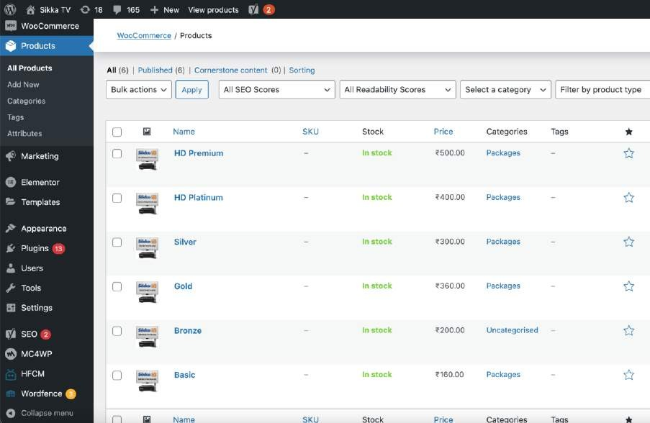

**Fig-6**

In Fig-6, we can see, we are on product’s column, I have added products we are selling here along with prices, plan’s name and stock status’s column. Under the products column on the left we can see an option to “add new” by which we can add more products to the list.

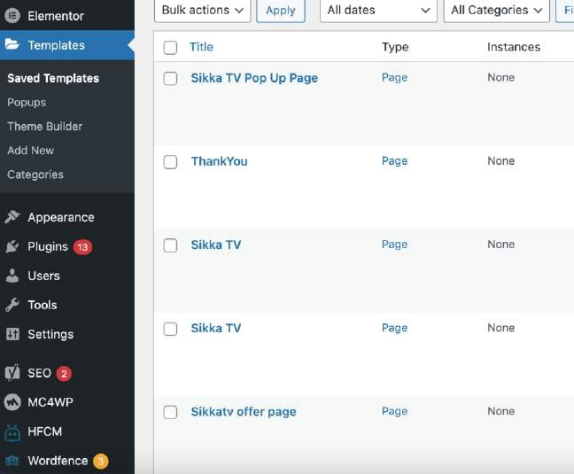

**Fig-7**

In Fig-7, we have another template button on the left which as we can see involves many titles under it like Pop up page, offer page , thank you page etc.

Giving it a definition, a website template is a predesigned resource that basically shows the structure of what all pages, desgins you have put on the website which is for the comprehensive layout and for displaying features of the website. It is a practice to provide web templates to help make web designing clear for any other designer who will be visiting the site. Here, I’ll like to conclude my work showing theme editor and it’s coding under appearance from Fig-8 onwards.

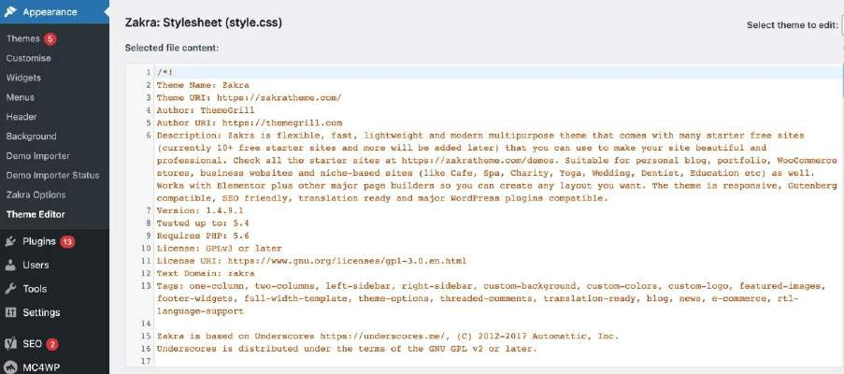

**Fig-8**

|  |  |  |
| --- | --- | --- |
| 23 | * | TABLE OF CONTENT |
| Z4 | # | RRset |
| 2 5 | # | 'rypoqxaphy |
| 26 | # | Elements |
| 27 | # | Forms |
| 28 | # | Navigations |
| 29 | # | Modules |
| 30 | # | Icons |
| 21 | # | Aooessibility |
| 32 | # | Alignments |
| 33 | # | Clearings |
| 34 |  | Header |
| 35 | # | WidgRts |
| 36 | # | Content |
| 37 | # | Posts and Pages |
| 28 | # | AsidRs |
| 39 | # | Comments |
| 40 | # | Footer |
| 41 | # | Nedia |
| 42 | # | captions |
| 43 | 4 | qa 11ex xes |
| 44 | # | Media Queries |
| 45 |  | Mobile |
| 46 | # | Tablets |

6 I II nokqunt-o {

1. margin: 0,
2. padding: O,
3. border: 0,
4. font-eize: ioo ;
5. font-etyie: inherit;
6. inherit:



«8 o»tiine: o;

69 vertical-align: baseline; 70 )

72 html (

7 3

oane-eerif;

74

7 5

76 }

-webkit-text-size-adjuat: 100%,

-ma-text-aise-adjust: 100¥;

79 margin: 0,

1. article,
2. aside,
3. details,
4. figcaption,
5. figure,
6. footer,
7. header,
8. main,
9. menu,
10. nav ,
11. section,
12. summary {
13. display: block,

95

96

1. audio,
2. canvas,
3. progress,
4. video {
5. display: inline-block,
6. vertical-align: baseline,
7. audio:not([controls]) {
8. display: nDne,
9. height: 0,

lll 112

113

114

115

116

117

118

119

12 0

121

1 2 2

1 2 3

1 2 4

1 2 5

1 2 6

1 2 7

1 2 8

1 2 9

13 0

131

132

133

template {

display: nDnR,

a {

background-color: transparent,



a:active,

a:hover {

outline: 0,

abbr[title] {

border-bottom: lpx dotted,



b, strong {

font-weight: 700,

dfn {

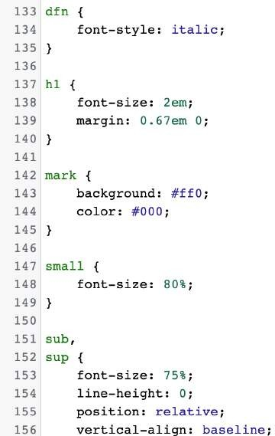

These were some of the coding screenshots I have applied on my website in order to achieve the basics of designs and themes and which are necessary before website can be published. All the code is with the help of programming languages like CSS, HTML. This was the end of explanation about my work towards the report and website.

**Conclusion**

I would like to conclude my report on a note that Web Development field has a lot of scope in it. Once you learn how to make a website, you’ll get a good paid start-up job after the college and you can learn a lot in it. For creating a good website, several rules have been mentioned in the report above which if kept in mind will make the website presentable and appealing to users visiting the site which’ll be benefit for you as they’ll be the ones who will be the converters in the end and earn you money.

**References**

1. [www.businessnewsdaily.com](http://www.businessnewsdaily.com/)

1. qdoc.tips
2. [www.dx.doi.org](http://www.dx.doi.org/)
3. blastbellyfatfast.com
4. The participatory turn in local policies A product of the market by Mazeaud-2019
5. A full lifecycle performance verification methodology for multicore s, by Holt, Jim Dastidar- 2012
6. [www.intechopen.com](http://www.intechopen.com/)

1. scholarworks.umass.edu
2. [www.geeksforgeeks.org](http://www.geeksforgeeks.org)